# ILLUMINATING INSIGHTS FROM UBER EXPENDITIONARY ANALYSIS

INTRODUCTION:

 Uber Driver Analysis refers to the Analyzing the number of trips taken by Uber drivers can provide insights into their overall activity and the demand for rides in specific areas.

PROBLEM DEFINITION AND DESIGN SINKING:

EMPATHY MAP

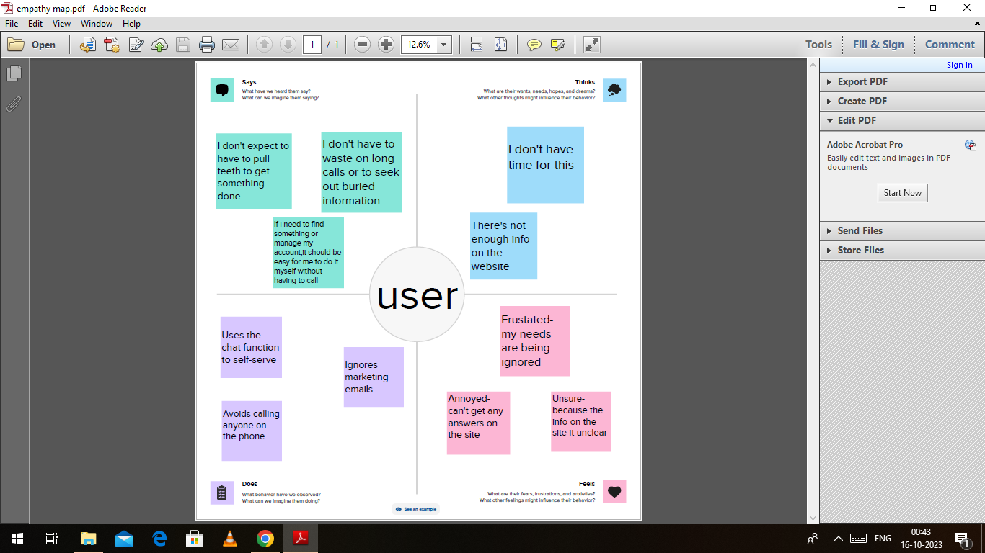

BRAINSTORM MAPPING:

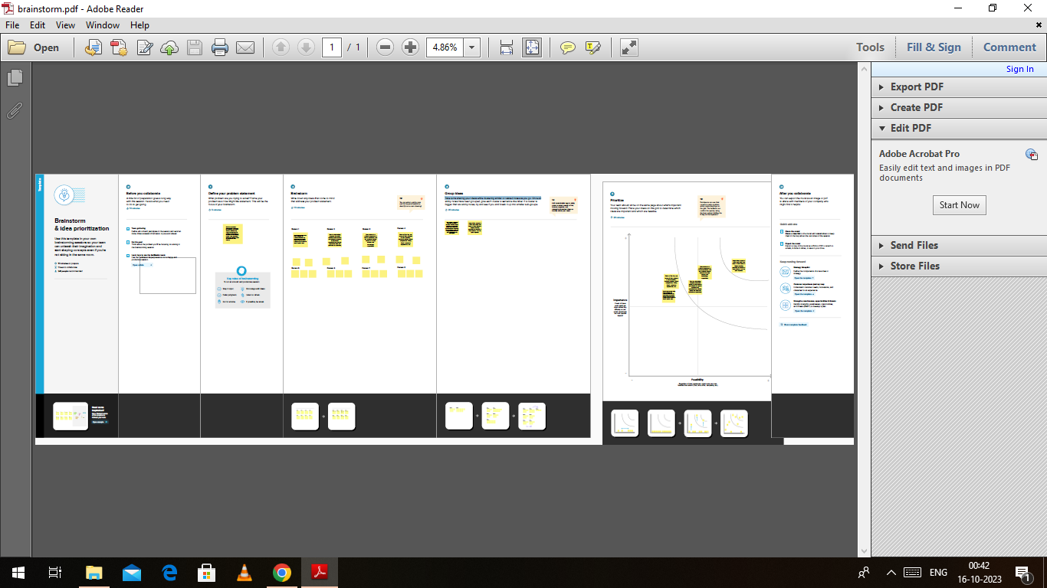

RESULTS:

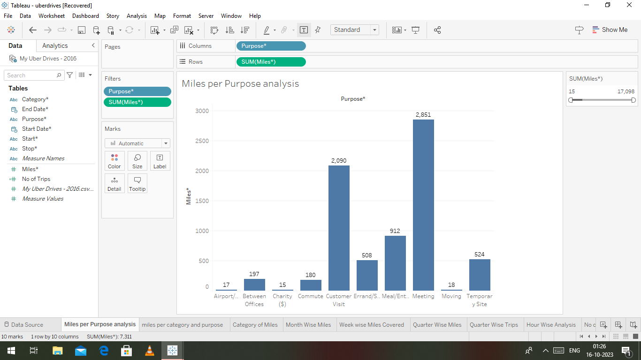

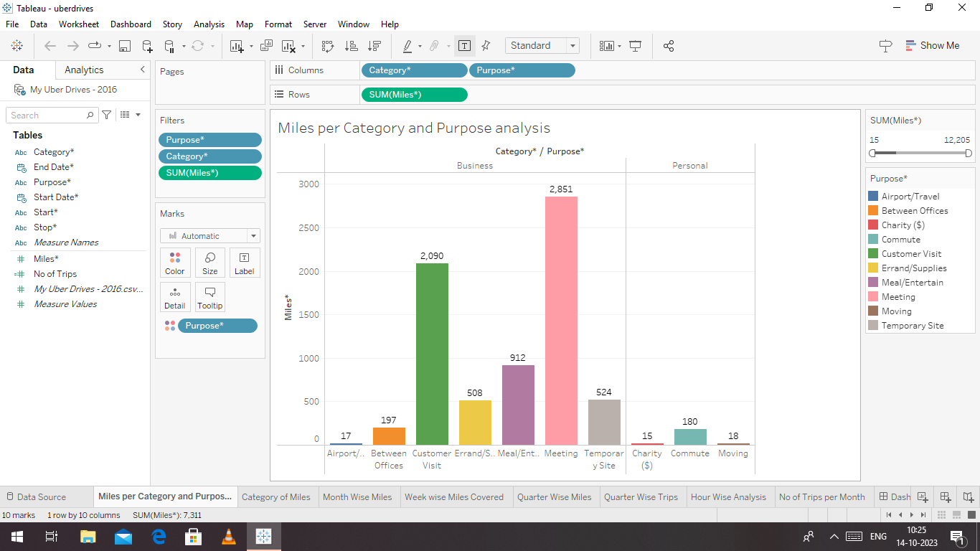

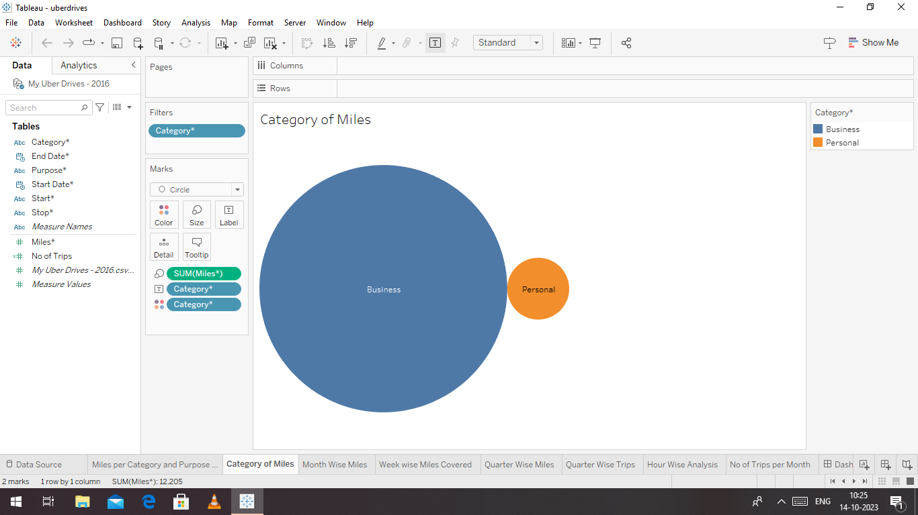

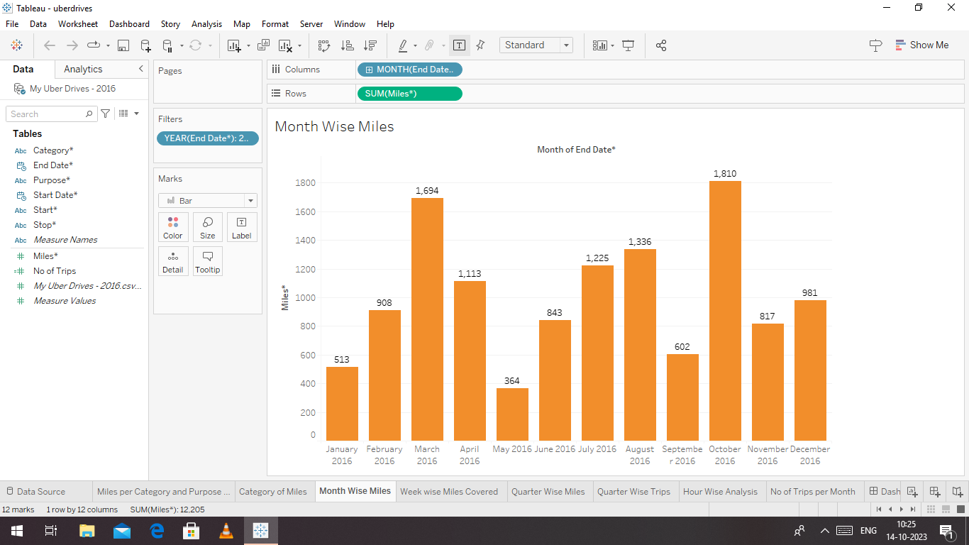

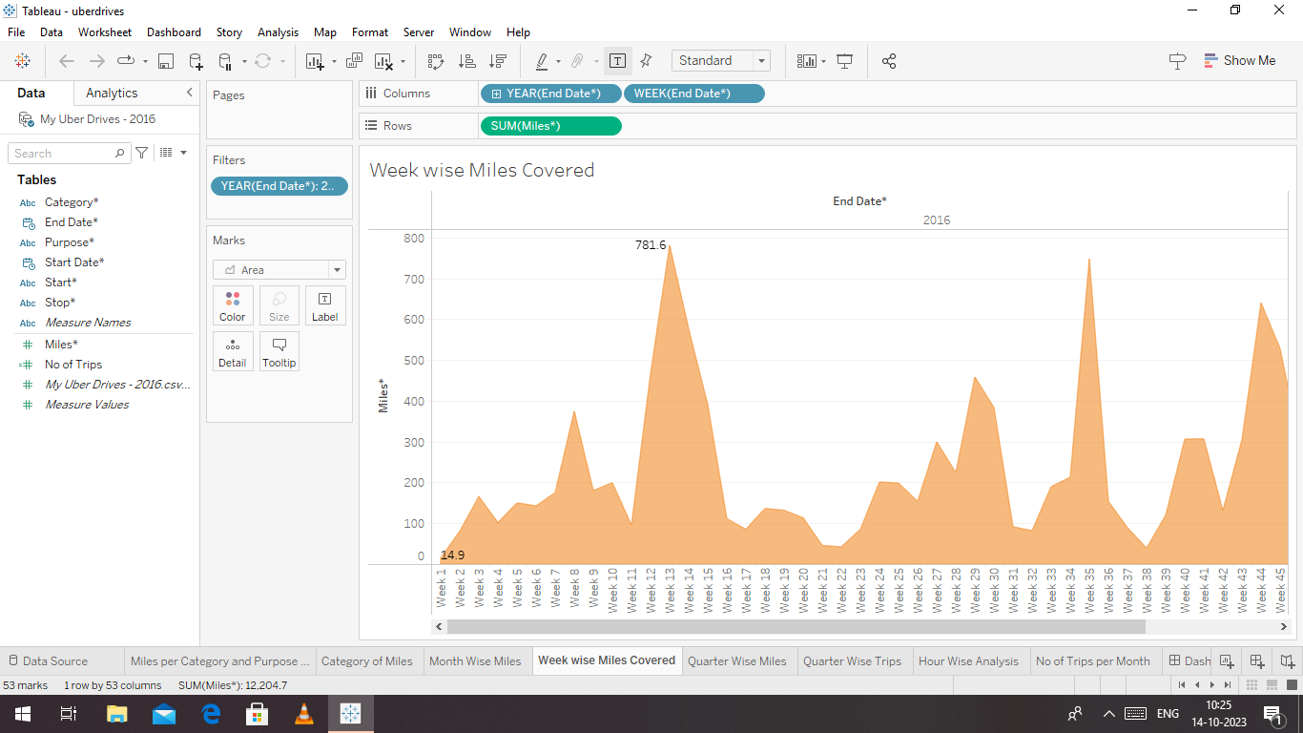

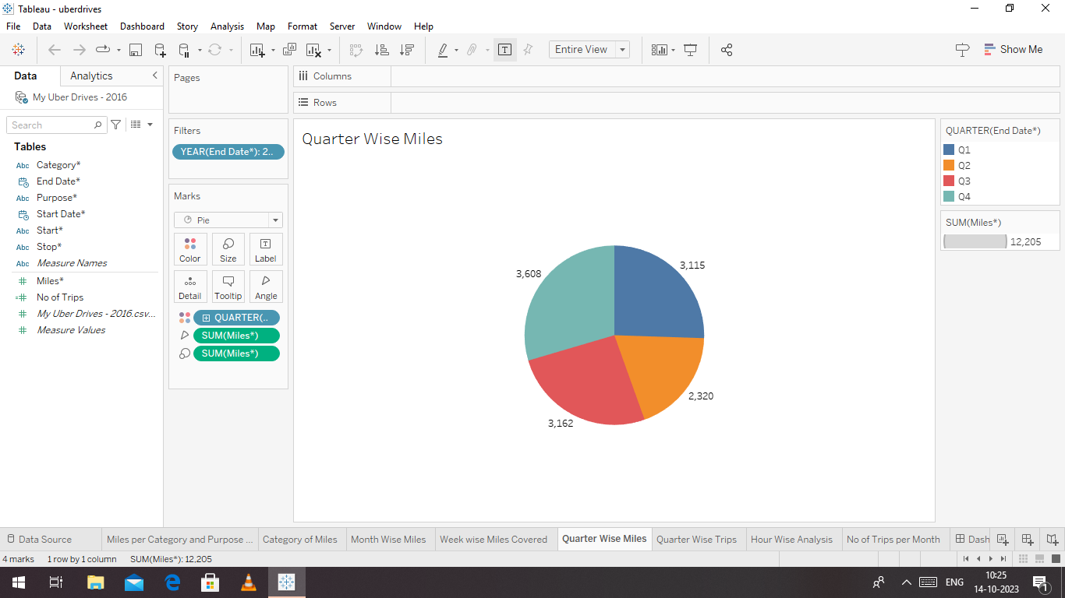

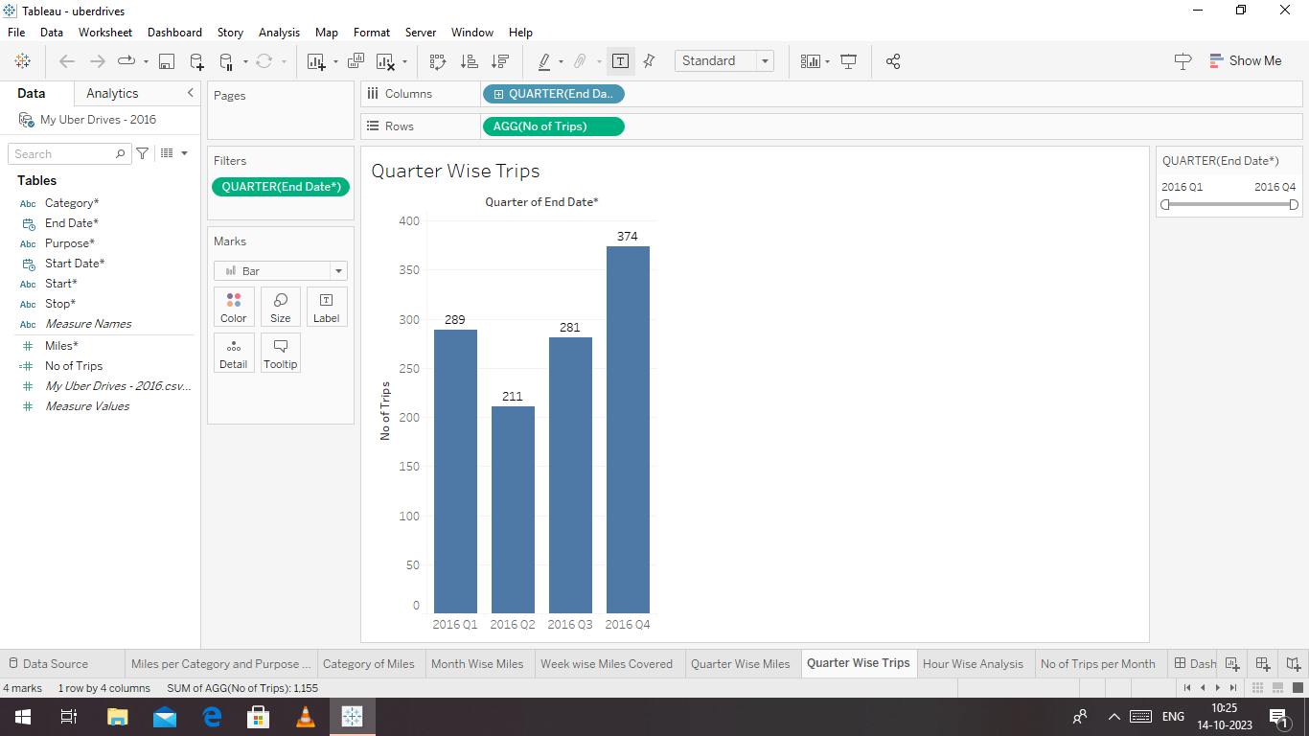

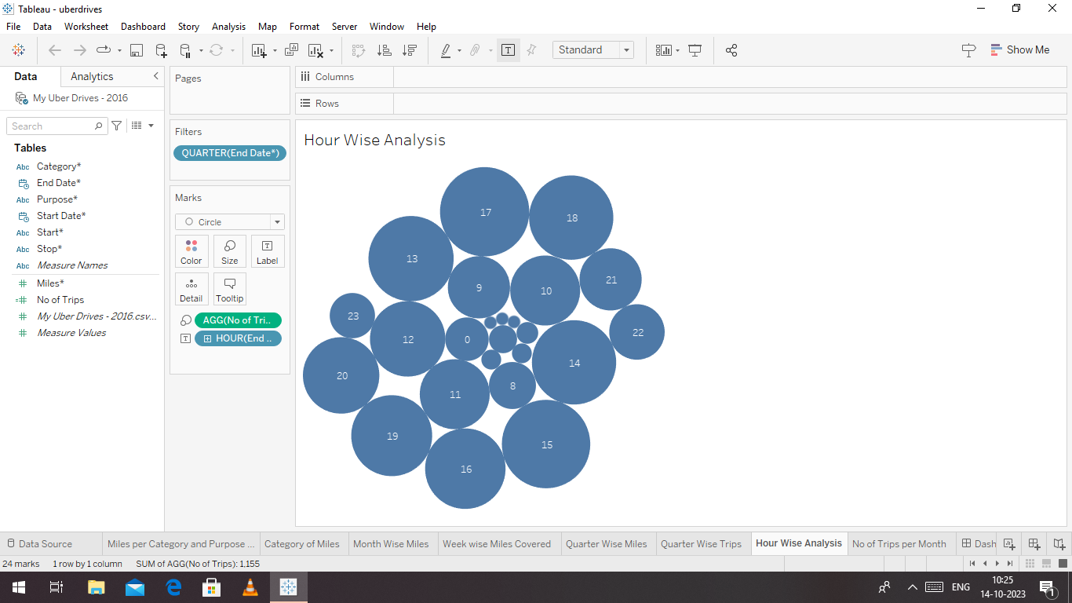

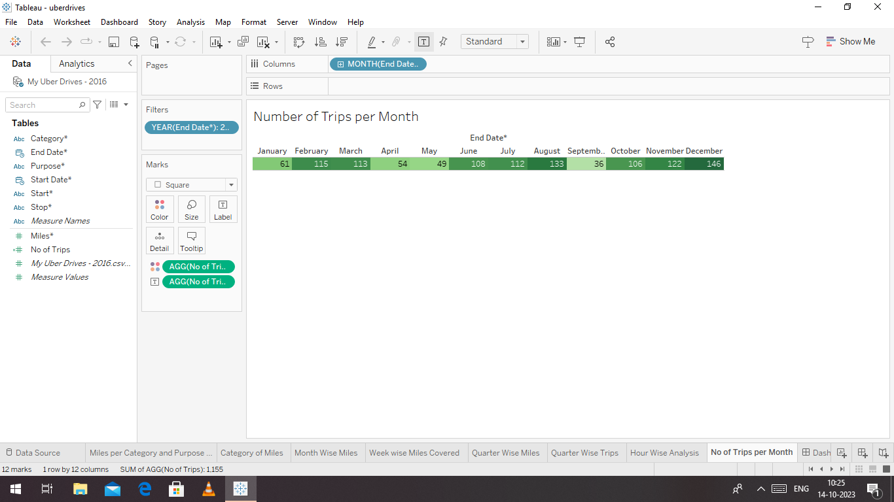

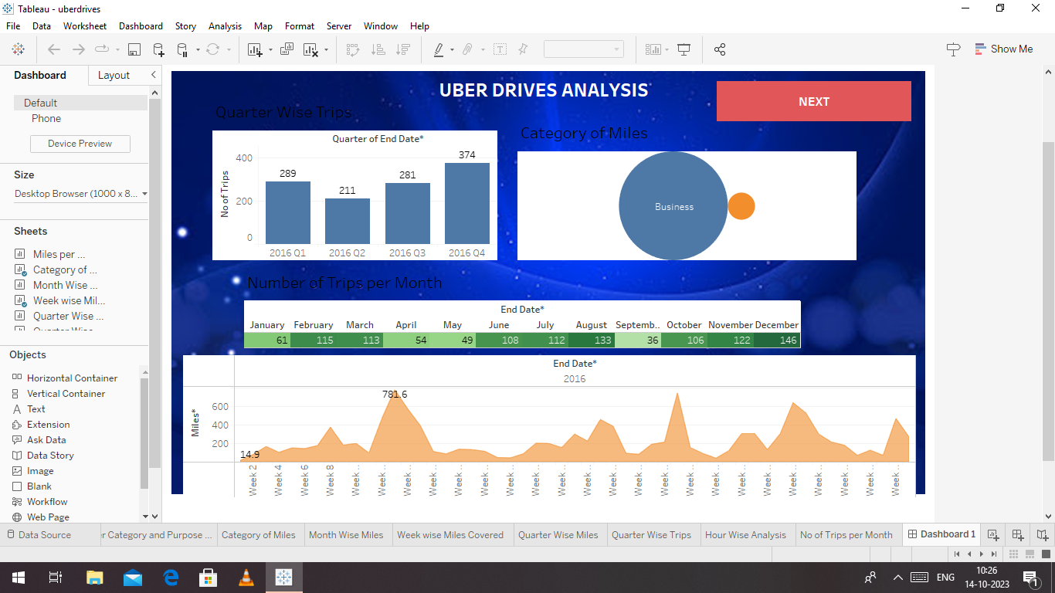

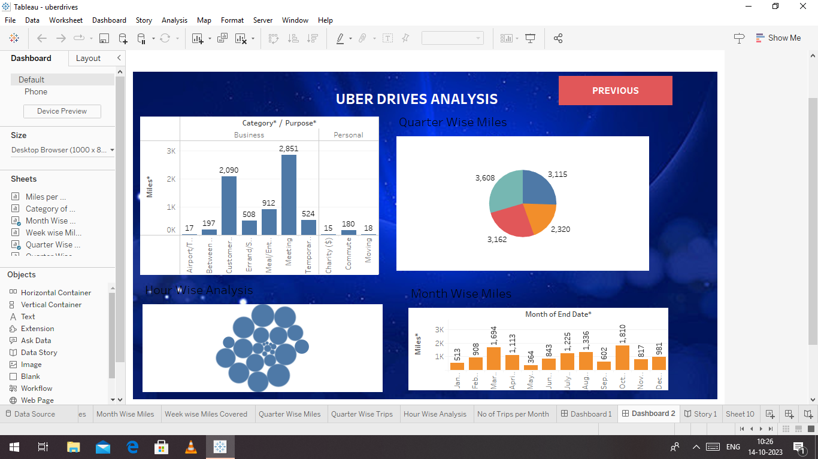

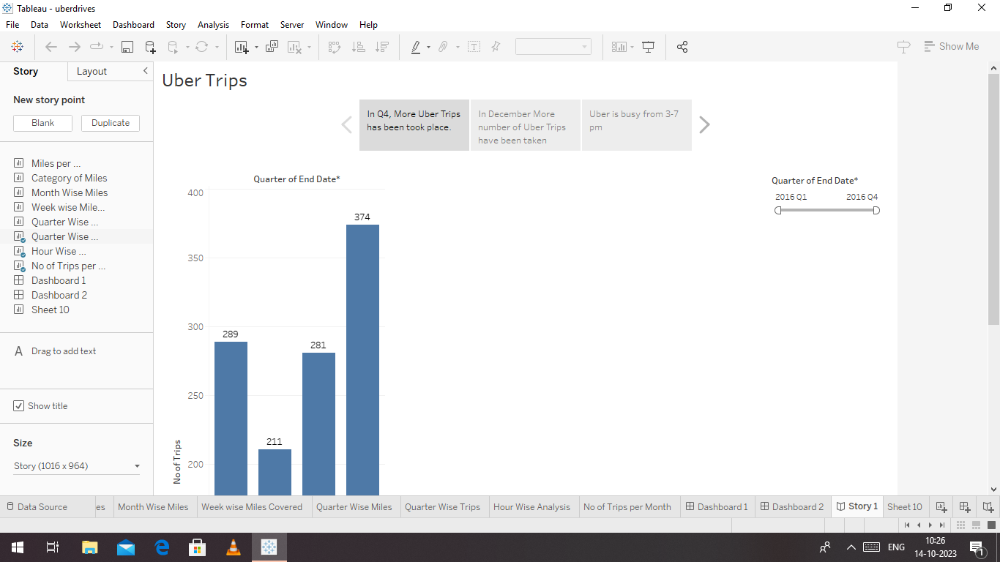

ADVANTAGES AND DISADVANTAGES:

ADVANATAGES:

* **Convenience**: Uber offers a convenient and user-friendly way to book rides. Users can request a ride with a few taps on their smartphones, eliminating the need to hail a taxi or wait for public transportation.
* **Availability**: Uber operates in many cities and regions, providing riders with access to transportation options even in areas where traditional taxis may be scarce.
* **Cost-Effective**: In some cases, Uber rides can be more cost-effective than traditional taxi services, especially when surge pricing is not in effect. It often provides upfront pricing, so riders know the cost before booking.

# DISADVANATAGES:

* **Surge Pricing**: During peak times or high demand, Uber may implement surge pricing, significantly increasing the cost of rides, which can be frustrating for riders.
* **Safety Concerns**: While Uber has implemented safety features, incidents involving rider/driver safety have occurred, raising concerns about the screening and monitoring of drivers.
* **Regulatory Issues**: Uber has faced regulatory challenges in many cities, leading to legal disputes and sometimes outright bans. This can create uncertainty for riders and drivers.

# APPLICATION:

Taking numbers, statistics, and digital metrics and transforming them into actionable insights, we utilize machine learning, AI, natural language processing, and advanced statistical modeling to implement automations and algorithms that enhance safety, amplify performance, improve our customer experience across Uber,

CONCLUSION:

This project will be very useful for illuminating uber expendigtionary analysis.

SCOPE:

The current world is witnessing many advancements and a lot of startups are evolving rigorously in the world for the past few years. All because of the emergence of on-demand ideas in the current business world with a lot of opportunities. The on-demand apps assist you to order or book anything from anywhere.